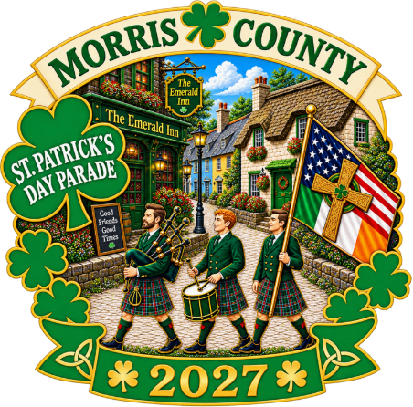

Application to Participate

St. Patrick’s Day Parade of Morris County, Inc.
Saturday, March 13, 2027
South Street, Morristown, NJ 07960

Help celebrate the Irish spirit in Morris County! The St. Patrick’s Day Parade brings the community together for a spectacular day of Irish music, dancing, bagpipes, marching bands, floats and family fun. It is a celebration of heritage, friendship and community pride that continues to be one of Morris County’s favorite traditions.

To apply, please complete this application and submit it to LOM@paradeday.com as soon as possible. The deadline for submissions is January 31, 2027.

I. ORGANIZATION STATUS:

________ Our organization marched in the 2026 St. Patrick’s Day Parade.

________ We are a new organization wishing to be placed on the waiting list.
(If new, you will be advised on or before February 1, 2027, if your organization can be added to the Line of March.)

II. ORGANIZATION DETAILS:

Organization Name: ________________________________________________

Address: _____________________________________________________

City: ______________________State: ___________ ZIP: ______________

Type of Organization: __________________________________________________

Contact Name: _______________________________________________________

Phone Number: __________________Email:________________________________

Number of participants in your marching group: _________
(Note: The size of your group may not exceed 150 people.)

Will your group have music?
Yes: □

No: □

If yes, what type of music? ___________________________

Who will be present and responsible for your group before and during the parade on March 13, 2027?

Name: ______________________________________________________________

Cell: _______________________________

III. ORIENTATION MEETING:

The Orientation Meeting is MANDATORY.

We will provide the time and location of this meeting once details are confirmed.

A representative of your organization must attend the parade orientation meeting. At this meeting, you will be advised of your division and place in the Line of March. Vehicle permits will be issued at this meeting.

Please acknowledge with your initials that a representative of your organization will attend the orientation meeting.

Acknowledged: ______________

IV. PARADE VEHICLES:

A limit of ONE vehicle per group. Vehicles must be clean and presentable. Construction vehicles are NOT permitted in the Line of March.

1) Will your group include motorcycles?
Yes: □
If yes, how many? __________
No: □

2) Will your group provide its own FLOAT?
Yes: □
If yes, will you have music? _____________ Type of music: __________________
No: □

3) Will your group provide its own vehicle?
Yes: □
If yes, what type of vehicle? __________________________
No: □

V. BANNERS:

Please be advised that your organization must have a banner or some other signage to identify itself. If a banner is needed, we have sponsors that can provide one at minimal cost. They are:

• Speedwell Printing 973-540-0400 info@speedwellprinting.com
• Morris Sign Company 973-386-1755 info@morrissignco.com

VI. BACKGROUND INFO:

Please provide a brief description of your organization. (This information will be used by the parade’s emcees to announce your group at the reviewing stand.) Please be clear and concise. Feel free to provide more information in a separate document.

______________________________________________________________________

______________________________________________________________________

______________________________________________________________________

If your organization will have an Irish theme (dress, flags, decorations, signage, etc.) on Parade Day, please describe it here.

______________________________________________________________________

Government officials who are marching must provide names and titles.

Name(s): ________________________________Title(s): _______________________

VII. PUBLIC SAFETY:

The parade goes on rain or shine. However, if there is a danger to public safety, the parade will be postponed. The parade make-up date is Saturday, March 20, 2027.

Please check the following box to confirm your organization will participate if the parade is postponed.

Confirmed: □

Please contact the Line of March Coordinator at: LOM@paradeday.com with questions.

VIII. CONDUCT AND SIGNAGE:

Please read the following statement and initial below.

To ensure the safety and enjoyment of all participants and spectators, the St. Patrick's Day Parade Committee reserves the right to deny access to any individual or group that displays inappropriate signage, uses offensive language, or engages in behavior deemed disrespectful or inconsistent with the values and spirit of the event.

All participants are expected to adhere to a family-friendly standard of conduct. The Parade Committee may, at its sole discretion, remove or prohibit any participant or group from marching if their conduct, signage, or language is inappropriate, offensive, or in violation of this policy.

By participating, all marchers agree to comply with these guidelines, and failure to do so will result in immediate removal from the parade or event.

Initial here: __________________________

PLEASE READ CAREFULLY BEFORE SIGNING:

On behalf of the firm/organization/institute/individuals noted above and all people in the entry described above, I, the undersigned, have been given the authority to sign on behalf of the entry and all people directly and indirectly related to the entry. I have read and agreed to comply with the St. Patrick’s Day Parade of Morris County, Inc.’s rules and regulations and all directions of parade officials.

I further agree that neither the St. Patrick’s Day Parade of Morris County, Inc . nor any of its officers, volunteers or committees will be liable for any injury to any people and/or damaged property suffered in connection with the parade and related activities as a result of the negligence of our organization.

I further agree to assure release and hold harmless the St. Patrick's Day Parade of Morris County, Inc., its officers, volunteers and committees from all claims for injury or damage caused by negligence by our organization or guests. I further agree that I hereby grant the St. Patrick’s Day Parade of Morris County, Inc. and its legal representatives and assignees the irrevocable and unrestricted rights to use and publish photographs and video of this entry and the entry’s participants, and people accompanying it, for purposes of publication, solicitation and sponsorship, advertising, broadcast and cablecast on television and radio, display on the Internet, and any other purpose, now and in the future, forever, by the St. Patrick’s Day Parade of Morris County, Inc., without any notice or further compensation to me.

I hereby release St. Patrick’s Day Parade of Morris County, Inc . and its legal representatives and assignees from all claims relating to said photography and/or other video imaging processes. I further undertake to provide all people directly or indirectly related to this entry with the St. Patrick’s Day Parade of Morris County, Inc . rules and regulations.

Note: By returning this application, you and your group agree to abide by all instructions, rules, and regulations established by the parade organizers.

Authorized Representative:

Print Name: ___________________________________ Phone Number: __________

Signature:___________________________________________Date:______________

